**Patient Visit Tables Relationships in AspEPR3**

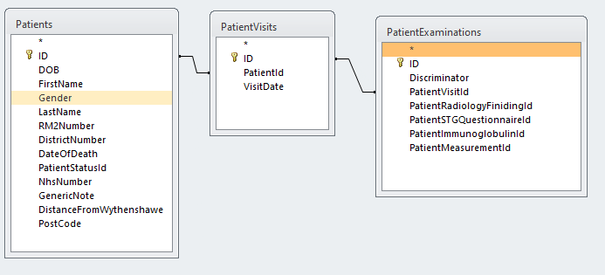

Patient Visits not implemented in Database.